Montecarlo method for Insulation Coordination in Power Transmission Lines.

Power Quality Assigment A2

# Introduce the simulated problem:

Our goal is to design and selection of insulation materials and protective devices to ensure the reliable and safe operation of the electrical system. In order to prevent electrical breakdown and flashovers that could lead to system failures, damage to equipment, or pose a risk to personnel.

By generating a random map of 10000 lightning hits within an area of 20000mx50000m, we are going to assess the effect they have in our transmission line.   
Our transmission line will be crossing the middle of map from side to side.

By modeling our TOVs, we will assess if the Level of Basic impulse isolation layer (BIL) of our line is sufficient enough to protect us against the effects of lightning hits caused TOVs.

# Steps of the Insulation Coordination method:

1. Modelling our lightning map with our transmission line.
2. Modelling each lightning with its current and caused overvoltage in our line. (Direct and indirect strikes)
3. Create our stress curve (up to impulse voltage of 100Kw).
4. Create our isolation curve (also up to 100Kw).
5. Calculate the risk curve from the two previous curve, asses results.

# Plots of spatial distribution of lightning strikes, plots of histograms (current, overvoltages) :

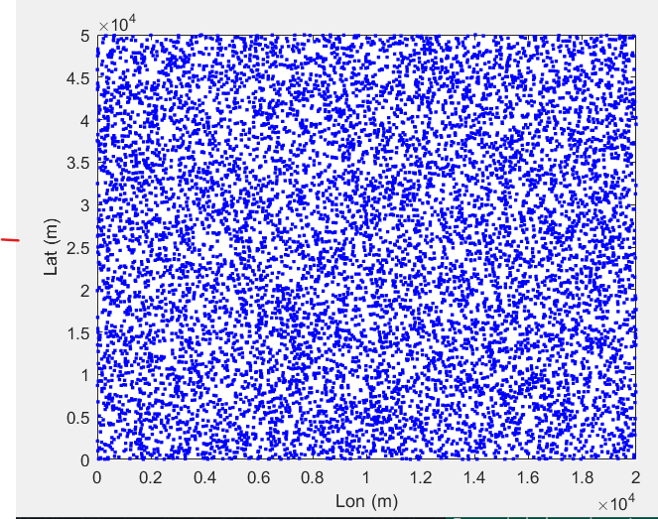

Figure 1, spatial distribution of lightning strikes

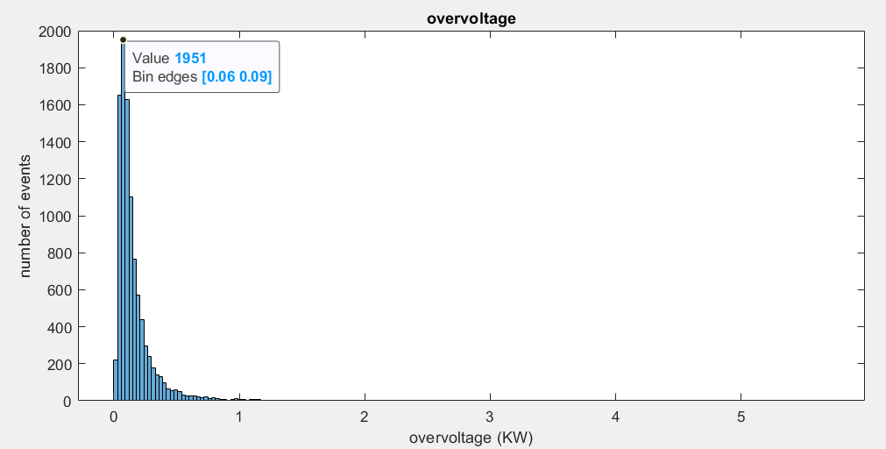

Figure 2, overvoltage histogram (Kv)

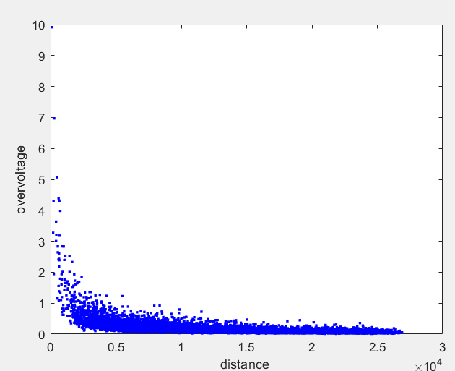

Figure , Overvoltage related to distance of each lightning to the line

The median value for overvoltage is 0.1107 KV

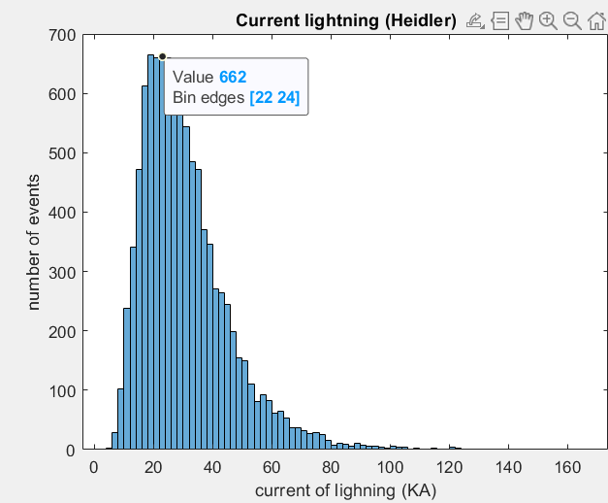

Figure 4, current histogram

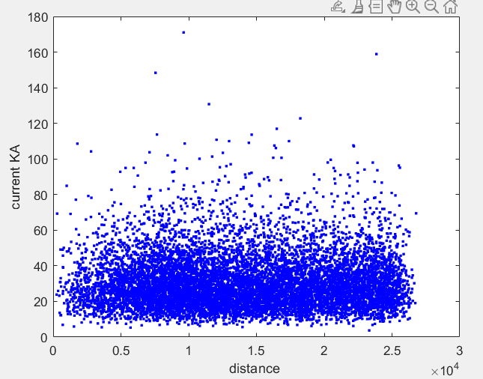

Figure , Current of each lightning, not related with distance

The median value for lightning current is 27.63KA

# Brief discussion about the obtained overvoltage values:

For the calculation of induced overvoltage’s due to indirect lightning strikes we used the rusk method:  
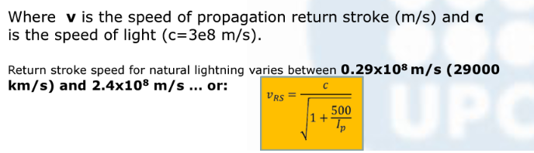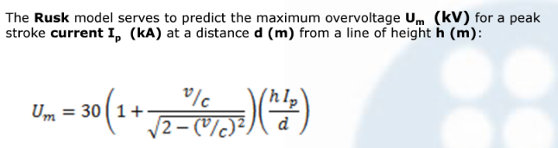

For strikes closer than 200m, we are reaching close to 12KV of induced overvoltage in the line  
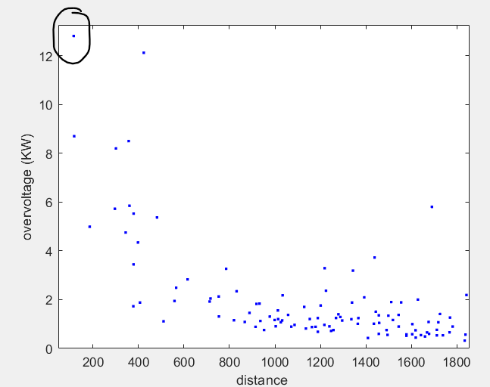

Figure , overrvoltage detail closest distances

After 5km the induced overvoltages are not that dependant of distance, the distribution flattens around the median value of 0.11Kv and a standard deviation of 0,77

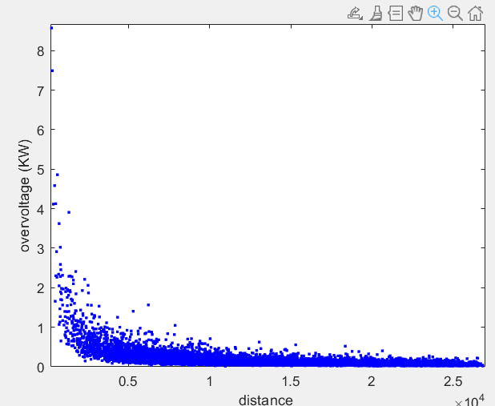

Figure , same as figure 3, overvoltage depending of distance

# Result and discussion of the obtained risk:

In order to calculate the risk of isolation failure we need first to calculate the stress and strength of isolation curves

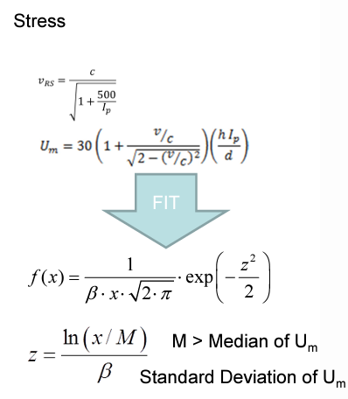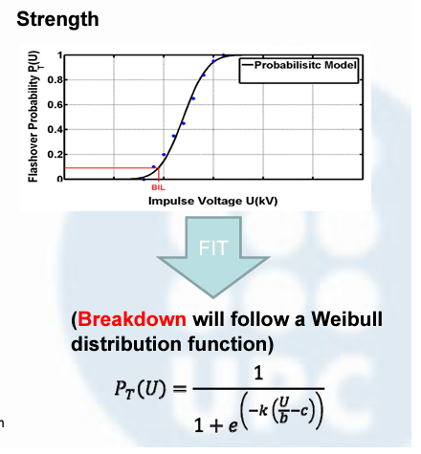

Figure , both formulas used to calculate our stress and strength distributions

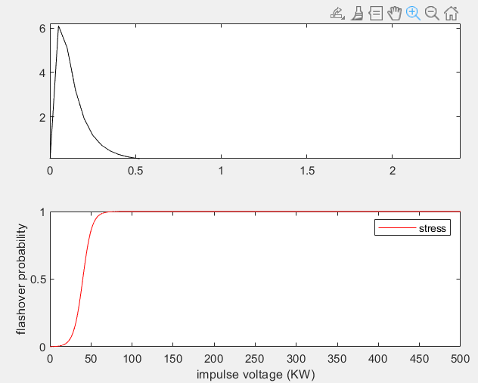

Figure , both stress and strength curves follow their respective expected distribution shapes

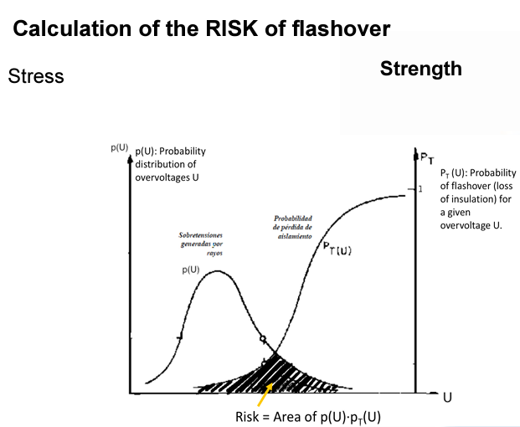

Figure , snap from the course slides, how to calculate the risk

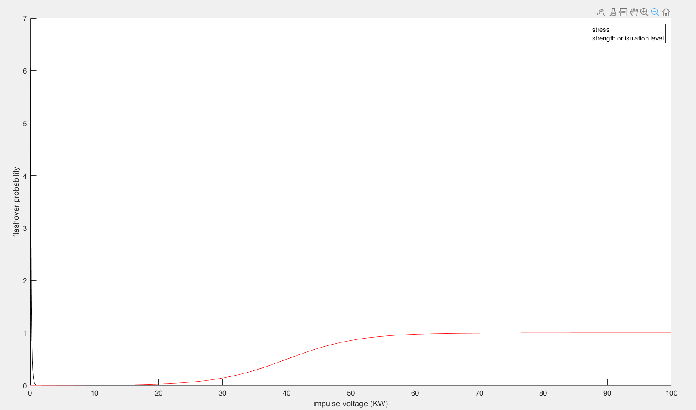

Figure , our stress and strength curves together

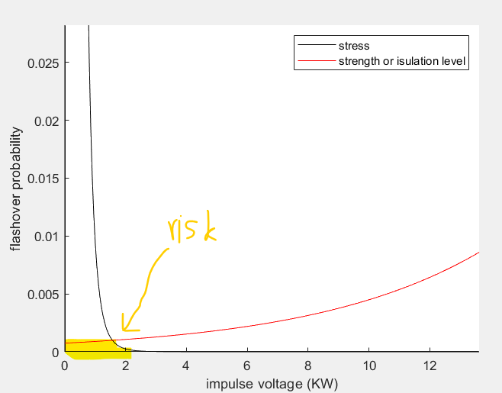

Figure , detail of stress and strength curves overlapping

Resulting risk of flashover after adding up the area under both curves = 0.0761%

# Annex, matlab code:

clear;

clc;

close all;

N = 10000;

for i = 1:N

data(i,1) = rand*20000;

data(i,2) = rand*50000;

end

plot(data(:,1),data(:,2),'b. ');

xlabel('Lon (m)')

ylabel('Lat (m)')

%calc stats

mediaX = mean(data(:,1));

medianaX = median(data(:,1));

mediaY = mean(data(:,2));

medianaY = median(data(:,2));

%calc ground flash density

%lightning current dis

mu=log(27.7); %peak current value > for any LLC

sigma=0.461; % standadr deviation

c = 3e8; %sp of light

%calc overvoltages due to near strike

h = 1+0.5; %(m)

%power line location in horizontal plane

x_loc = 10000;%now we do an specific point

y_loc = 25000;

for i = 1:1:N

data(i,1) = rand*20000; % x

data(i,2) = rand*50000; % y

data(i,3) = lognrnd(mu,sigma); %random log normal distribution of the lightning peak current

data(i,4) = c/(sqrt(1+(500/data(i,3)))); %return stroke speed.

test(i,1) = log(data(i,3)); % log (I) to calculate

%check if not a direct strike

d(i,1) = sqrt((x_loc-data(i,1))^2 +(y_loc-data(i,2))^2);%distance of the overvoltage, now from a single point

data(i,5) = 30*(1+(data(i,4)/c)/sqrt(2-(data(i,4)/c)^2))*(h*data(i,3)/d(i,1)); %overvoltage value for each strike

test(i,2) = log(data(i,5));

end

% current statistics

median_I=median(data(:,3));

std_I=std(test(:,1));

%overvoltage stats

median_U=median(data(:,5));

std_U=std(test(:,2));

i=1;

for U=0.0001:0.05:500 %distribution value of the stress curve, we choose 500KW but we could choose more than that, it will chop the infinit""" distribution

P_U(i,1)=U;

z=log(U/median_U)/std_U;

P_U(i,2)= (1/(std_U*U*sqrt(2*pi)))*exp(-1*(z^2)/2);

i=i+1;

end

%cumulative distribution function, not used a lot

[fil,col]=size(P_U);%get size of P_U, use the size as index

acc(1,1)=0;

j=2;

for i=2:1:fil

acc(j,1)=acc(j-1,1)+P_U(i,2)*(P_U(i,1)-P_U(i-1,1));

j=j+1;

end

%k=1.8 b=10 c=4 parameter of weibull distribution (shape and scale)

i=1;

for U=0.0001:0.05:500 %i believe this is the isulation curve somehow

Pt_U(i,1)=U;

Pt_U(i,2)= (1/(1+exp(-1.8*((U/10)-4))));

i=i+1;

end

%calculation of risk, convolution

[fil,col]=size(P_U);

risk=0;

deltaU= (P_U(2,1)-P_U(1,1));

for i=1:fil

risk=risk + (P_U(i,2)*Pt_U(i,2))*deltaU;

end

risk

figure();

hold on

plot(P_U(:,1),P_U(:,2),'k'); % doesnt make a lot of sense because also depends of DISTANCE so , if there is a grat induced overvoltage it could be that its just too close to the power line

hold on

plot(Pt_U(:,1),Pt_U(:,2),'r'); %insulation curve? he calls it strength

xlabel('impulse voltage (KW)')

ylabel('flashover probability')

legend('stress','strength or isulation level');

hold off

figure();

plot(d(:,1),data(:,3),'b. ');

xlabel('distance ')

ylabel('current KA')

figure();

plot(d(:,1),data(:,5),'b. '); % doesnt make a lot of sense because also depends of DISTANCE so , if there is a grat induced overvoltage it could be that its just too close to the power line

xlabel('distance ')

ylabel('overvoltage (KW)')

figure();

histogram(data(:,5));

title('overvoltage');

xlabel('overvoltage (KW)')

ylabel('number of events')

figure();

plot(data(:,3),data(:,5),'b. ');

title('Current vs overvoltage');

xlabel('current of lighning (KA)')

ylabel('overvoltage KV')